Dear Member:

Brownsville Educators Stand Together (BEST AFT) members are encouraged to participate in the upcoming Charter Election scheduled for Friday, May 17, 2024. Each member will have an opportunity to vote by secret ballot to become a full affiliate of the 1.7-million-member American Federation of Teachers, vote to ratify a proposed local constitution.
by BEST AFT organizing committee and vote to elect officers/leaders who would serve on the BEST AFT Executive Board.

At the February BEST AFT leadership meeting, our inaugural Elections Committee was selected. As chairperson of this committee, it is my pleasure to open nominations for nine (9) Executive Board positions which includes the positions of President, Vice President, Treasurer, Secretary, Parliamentarian, an Elementary School Representative, a Secondary School Representative, a Certified Non-Teacher Representative, and a Classified Representative. All members may nominate themselves or another BEST AFT member who has been a member for a 12-month period or longer. Only those members serving on the Elections Committee may not be nominated as this committee is responsible for overseeing the May 1, 2024, Charter Election.

Nominations are due no later than Monday, April 29, 2024. Enclosed is a nomination application and a description of Officer duties. Please return this form to the local BEST AFT office before the deadline. Nominations may also be emailed to the Elections Committee, Attn: Linda J. Torres, at bestaftbisd@gmail.com

Note: If you wish to nominate for more than one position, you may make or request more copies of the nomination form.

Following the deadline for nominations, a sample ballot listing all items on the Charter Election ballot will be mailed to each member. This sample ballot will also list the names of members nominated for a particular Executive Board position. Again, a vote will take place by secret ballot on Friday, May 17, 2024, at the Royal Event Center. Polls will be open from the hours of 6:30 p.m. to 8:30 p.m. Early voting will be offered at the local BEST AFT conference room on May 11 from 12:00 p.m. to 5:00 p.m. and on May 13 – May 15 from the hours of 3:00 p.m. to 7:00 p.m. to give every member an opportunity to visit the local office to vote.

For questions regarding nominations or the upcoming charter vote, please call 956/410-2539 or visit our web site at www.texasaft.org/best-aft-2024, where more information and updates will be posted.

In Unity,
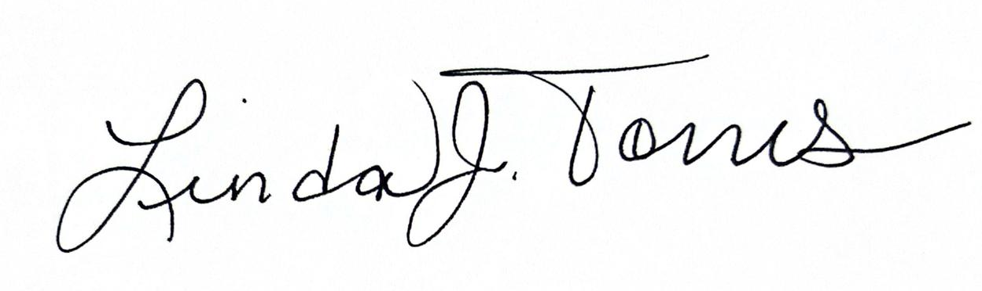

Linda J. Torres
Elections Committee Chairperson

Enclosure: Nomination Application due by April 29, 2024, Officer Descriptions

